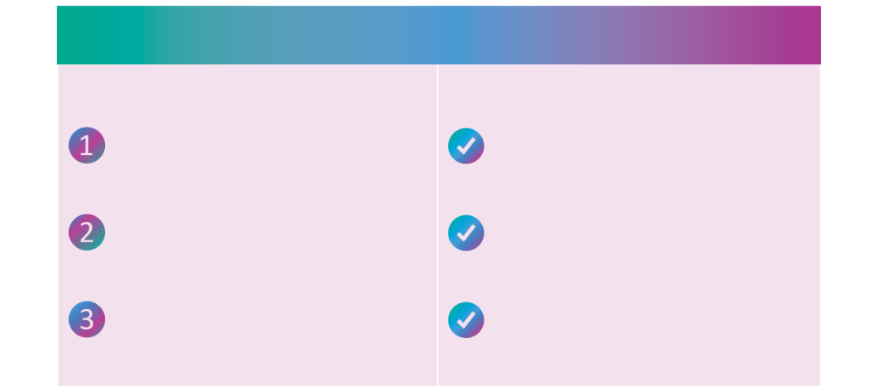
How to get started:
With your LSA, you can:
The personal benefits you want.
Your new Lifestyle Spending Account is here!
We’re excited to announce a new benefit: Lifestyle Spending Account (LSA).
We’re giving you choice and flexibility in how you use your personal benefits.
Log in to your Espresa account
[Insert Company Link]
Get reimbursed for gym memberships, wellness apps, and mindfulness programs


Use funds for professional development, online courses, or certifications

Start using your LSA!
Explore your eligible categories
[Insert Company Guidelines]

Warmly,
[NAME]
[CONTACT]

For questions about your eligibility or program details, please contact your HR team: [Insert HR team email].
Download the Espresa App on Apple or Google Play and explore your benefits today!
Download the App
Support family care, pet care, commuting, home office, and more

