
Find pre-approved options for fitness, family care, learning, and more. No guesswork, just click and go, finding top brands like:
- Amazon
- Apple
- Uber
Shop the Marketplace:
Three Ways to use Your LSA!
Looking for ways to leverage your lifestyle spending account? Take a look at the ways you can make the most of our benefits.

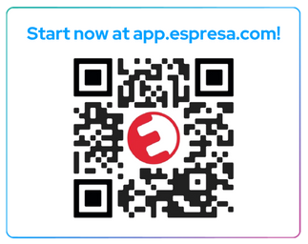
Pay Up Front, Get Reimbursed:
Already purchased something eligible? Upload your receipt in the Espresa app and get reimbursed quickly through your paycheck or a direct deposit! All you need is to:
- Log into the Espresa app
- Upload your receipt
- Get reimbursed
Use Your Global LSA Debit Card:
Enjoy safe, instant purchasing anywhere Visa is accepted, avoiding reimbursements altogether. The card offers:
- Secure purchases
- Global availability
- Digital wallet compatibility

