Your Lifestyle Spending Account (LSA) is ready to cover your expenses, but do you know what is covered? To get started, look into expenses like:
Do you know what’s in your LSA?
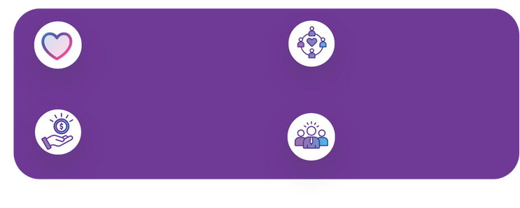
Fund ergonomic furniture, transit passes, standing desks
Family care, rideshare apps, doggy day care, headphones
Home & Commuting -
Reimbursements for gym memberships, personal training, meditation, wellness apps
Wellness & Fitness -
Career Growth
Select from courses, coaching, events, and conferences

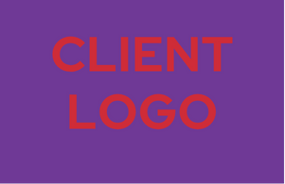

Download the Espresa App on Apple or Google Play
Ask your HR team which expenses fit into your benefits plan
All you have to do is log in, spend smart, and upload your receipt!
Your Lifestyle Spending Account (LSA) is ready to cover your expenses, but do you know what is covered? To get started, look into expenses like:
Everyday Life -

